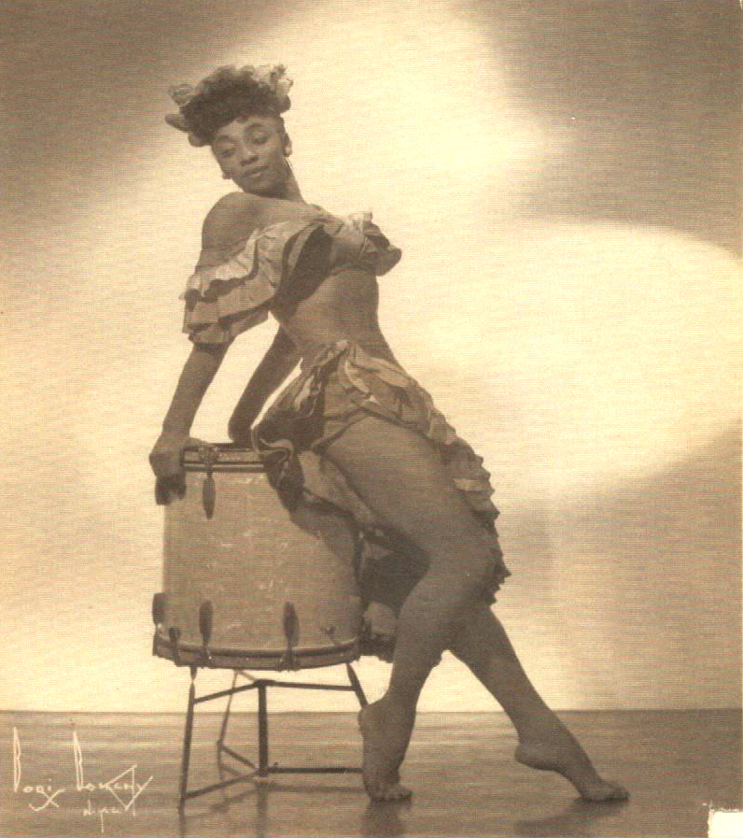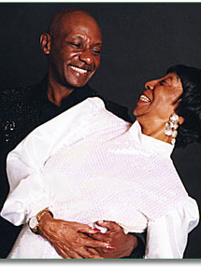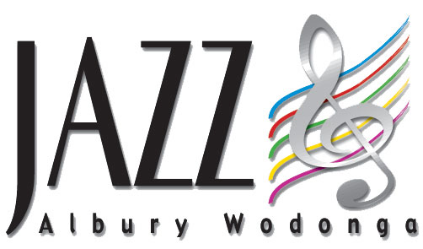
“It Don’t Mean A Thing…If It Ain’t Got That Swing”
A Tribute to Swing, Jazz & Tap with Queen of Swing Norma Miller
A portion of the proceeds from all events will benefit Collins Productions for sponsoring these events. They are 501 (c) 3, dedicated to teaching children of all ages how to let their feet express their feelings through music…Collins Productions brings to the Twin Cities some of the country's top talent, including many of our nation's living legends for dance classes, programs and special events. Please visit their website at www.collinsproductions.org
Queen of Swing Norma Miller returns to Minnesota for It Don’t Mean a Thing…If It Ain’t Got That Swing – A Tribute to Swing, Jazz & Tap celebrating the history, music and dance that came out of the Harlem Renaissance. Norma Miller will be attending a series of dance events and film screenings of the documentary “Queen of Swing” throughout the Twin City area.

At each event Ms. Miller will be on hand to share stories of her years on the road being a participant in American Civil Rights history (integrating the first U. S. public facility- the Savoy Ballroom, as well as Las Vegas hotels with Sammie Davis Jr. & Frank Sinatra) and to sign copies of Al Governor’s children book based on Norma’s childhood in Harlem, “Stompin at the Savoy”.
MEET NORMA MILLER!

Film Screenings &
Book Signings
in Minneapolis
Redeemer Lutheran Church
Special Children’s Screening
Friday, September 14th4:30 PM
1800 Glenwood Avenue, Minneapolis, MN 55405 (Corner of Logan) (612) 374-4169
Suggested Donation: Optional $1 for children and seniors and $5 for adults

Jordan New Life Church
Friday, September 14th 7:00 PM
1922 25th Avenue (26th & Newton Avenue N.) Minneapolis, Minnesota
Suggested Donation: $10 for adults and $5 for seniors and youth

Stompin at the Savoy, the children’s books will be available on a first come, first serve basis for $15.00. Swinging at the Savoy: The Memoir of a Jazz Dancer may be available for adults for $25.00. The DVD Queen of Swing can be purchased for $20.00

For more information about both events please call Michelle Johnson (651) 341-9636 For more information about Norma Miller, visit www.normamillerswings.com

